1. **Create user "nikhil" with home directory set as "/home/nikhil"  
          a) nikhil user should have "/bin/sh" shell for his environment  
          b) His password should expire in 9 days and 2 days before password expiry, he should get warning. User account must expire in 1 month from creation date  
         c) Give him root privileges to start/stop cron daemon.**

**Ans:**

* Created a user “nikhil” using **useradd** command and setting its home directory as “/home/nikhil” by using **–d**. And **–m** will help to create a home directory.
* For setting environment used –s with useradd so that the shell should be “/bin/sh”.

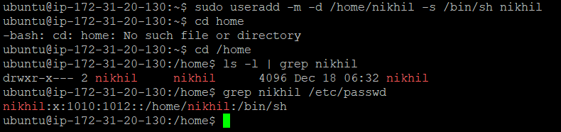

* Used **chage** command to set the account’s aging info. **–M** for maximum no of days after which password should expire, **-W** is for the warning day before password expires and **–E** for the account expiration date.

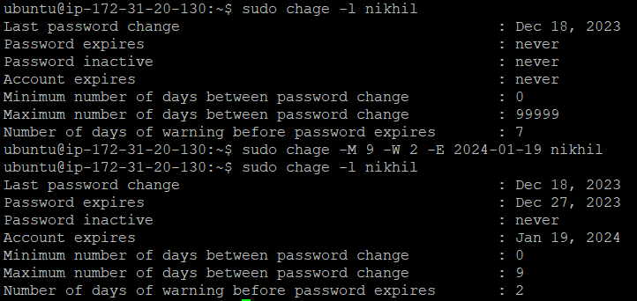

* To allow a user for root privileges, entered inside the config mode of sudo by using **visudo**.

C:\Users\Arnab\Pictures\Screenshots\Screenshot 2023-12-19 005105.png

* Added nikhil in the privilege section and given ALL permissions so that he can also be a Super User.

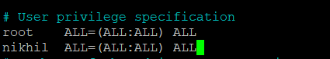

* To check weather the user is set or not logined in it and entered the command to check : **sudo –l.**

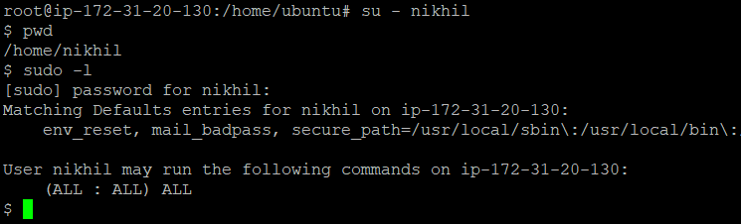

1. **Inside folder "/" , create new home directory as "nikhil" (/nikhil) and setup this folder as a home directory for user "nikhil"**

Ans:

* Created a home directory for nikhil inside “/”.

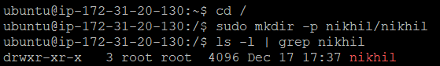

* Added the user nikhil and set his password.
* Changed the ownership of the folder “/nikhil/nikhil” by using **chown** command.
* And by using **usermod** command pushed the user “nikhil” inside the directory which was created.

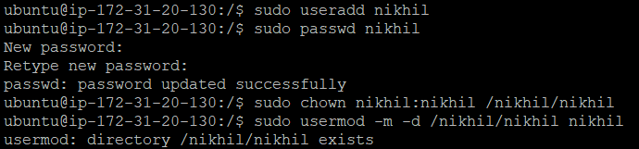

* Checked using different ways to clarify the user is present in its respective directory.

